Use Case Diagram:
Over View Use Case Diagram:

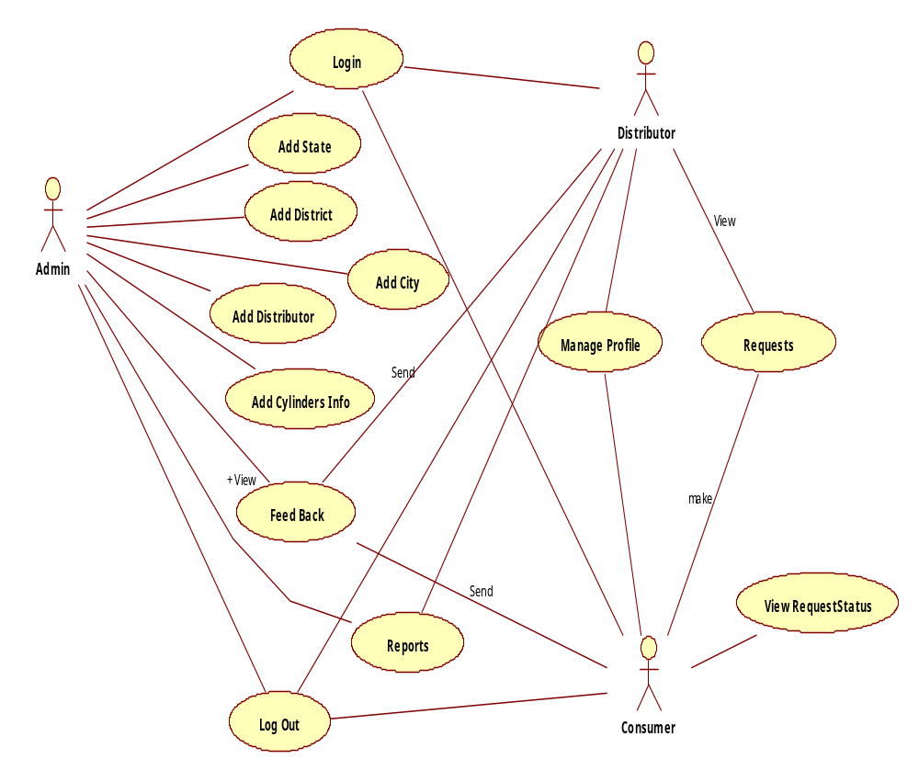
Admin Use Case Diagram:
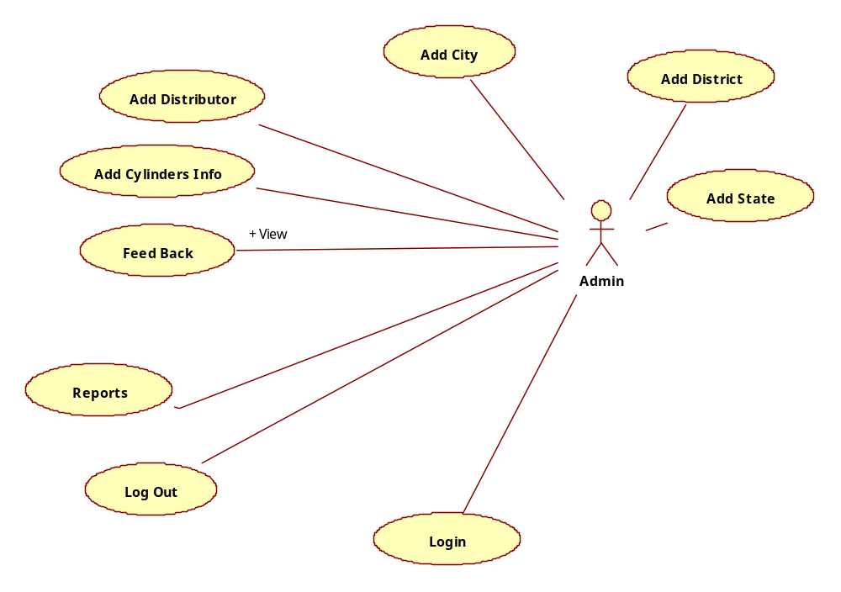
Distributor Use Case Diagram:
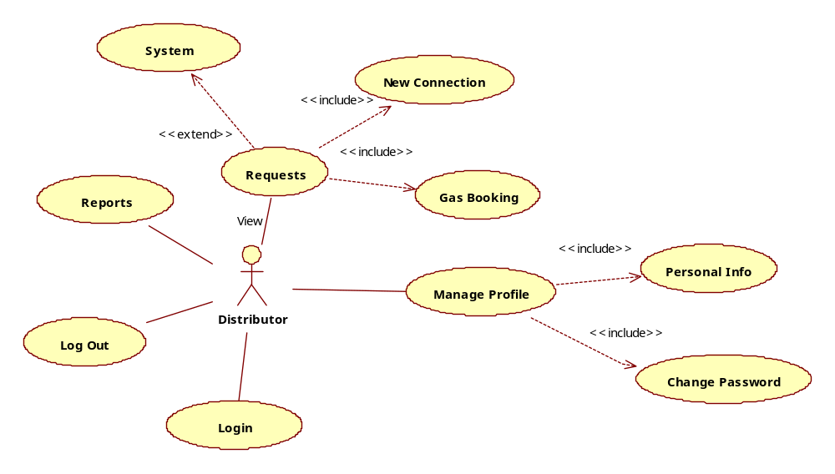
Consumer Use Case Diagram:

